Take Home Tuesday
Parent Weekly Bulletin
December 19th to December 21st

Green Oaks Academy

Monday 12/19 | Tuesday 12/20 | Wednesday 12/21
8:25 A.M. Start  3:10 P.M. Dismissal | 8:25 A.M. Start  3:10 P.M. Dismissal | 8:25 A.M. Start  Minimum Day  3:10 P.M. Dismissal  See you on Wednesday January 11, 2017!

Dear Parents and Families,
Thank you for all of you who attended our La Posada Celebration last week. We had over 200 people join us for a wonderful evening, and it was so much fun! Our event would not have been possible without the help of our dedicated parents and staff. I want to thank Ms. Nancy, Ms. Imelda, Our Office Manager Ms. Paloma, ________ (put names of yard duties, moms who cooked and helped), and Mr. Marco Duarte for helping with decorations, cooking delicious foods, and/or for helping with clean up at the end.

Another special thanks goes out to Moms Against Poverty who donated prizes for the raffle and toys for our students at La Posada. I received feedback from concerned parents and staff during and after La Posada that the toy distribution was overwhelming, and some of our students did not get gifts. It was very sad to hear this. To ensure that all our students will get a gift next year, gifts will instead be given out in the classroom rather than at La Posada. This will ensure that we have a fun filled event for everyone next year! Moms Against Poverty also donated additional Target gift cards to our school. We will be doing a random drawing at school and calling those who won to come to the office this week to pick up their gift cards.

Wishing you a wonderful break with lots of delicious food, memorable moments with your loved ones, and relaxation! Be sure to read to your child and remind them to read. School does not resume until Wednesday January 11, 2017. See you next year!—Sincerely, Principal Bui

Photos of the previous week for your enjoyment!
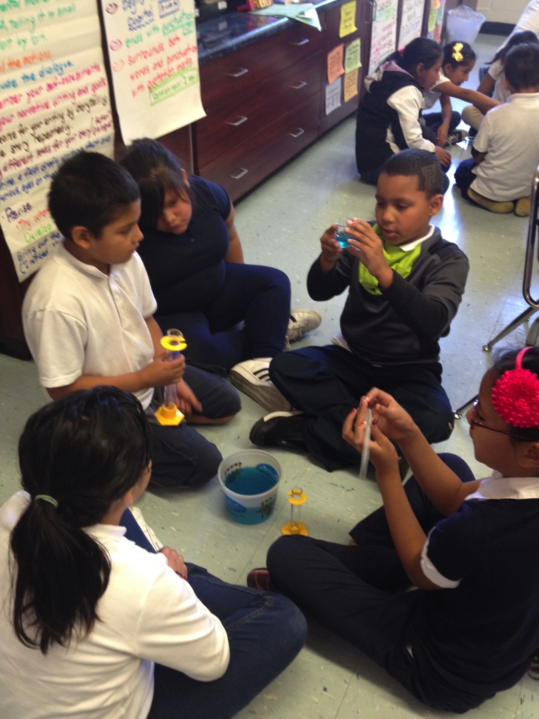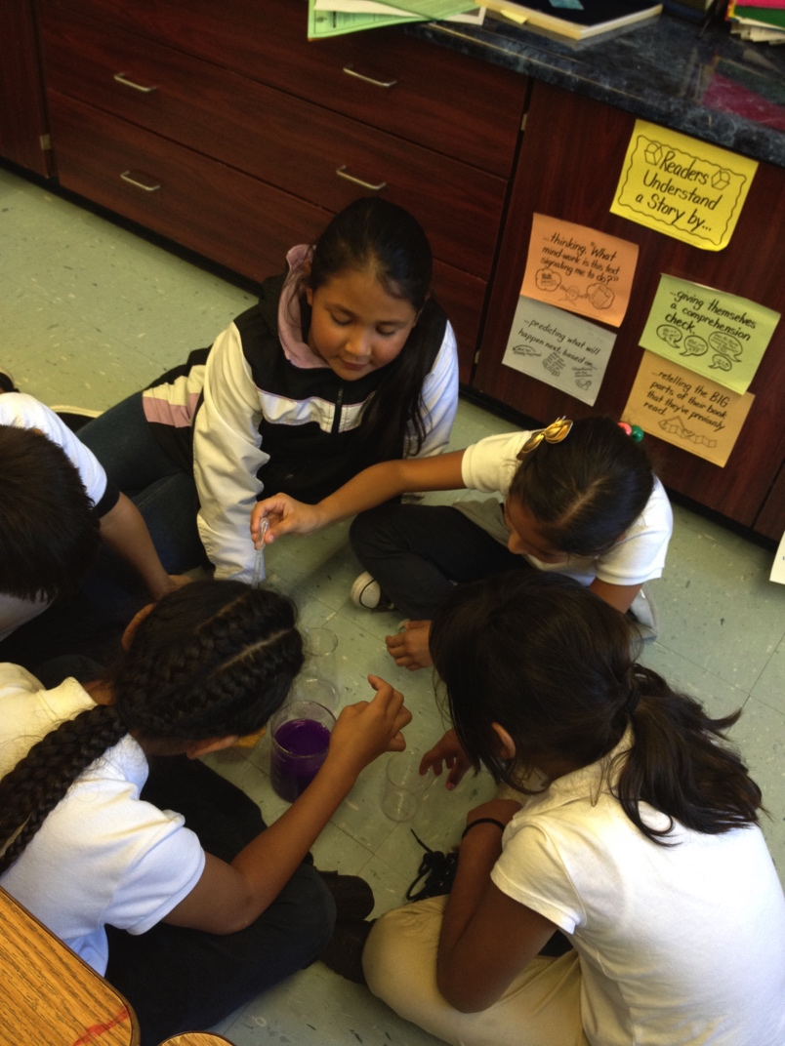

Ms. Valencia’s Class doing a science lab and Secret Santa
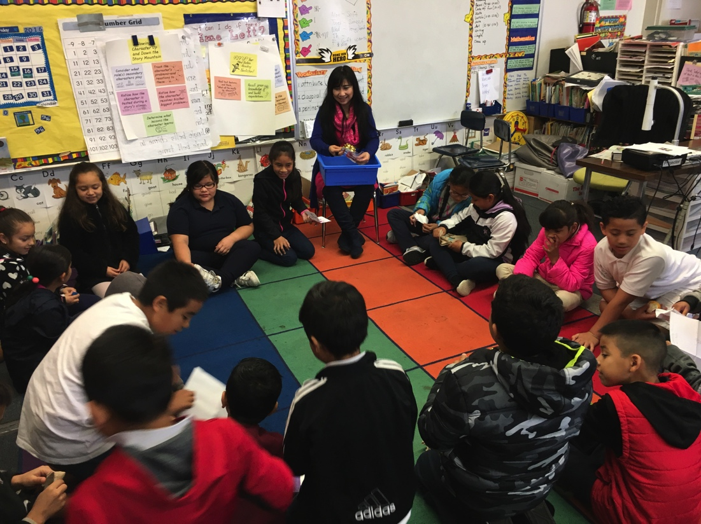

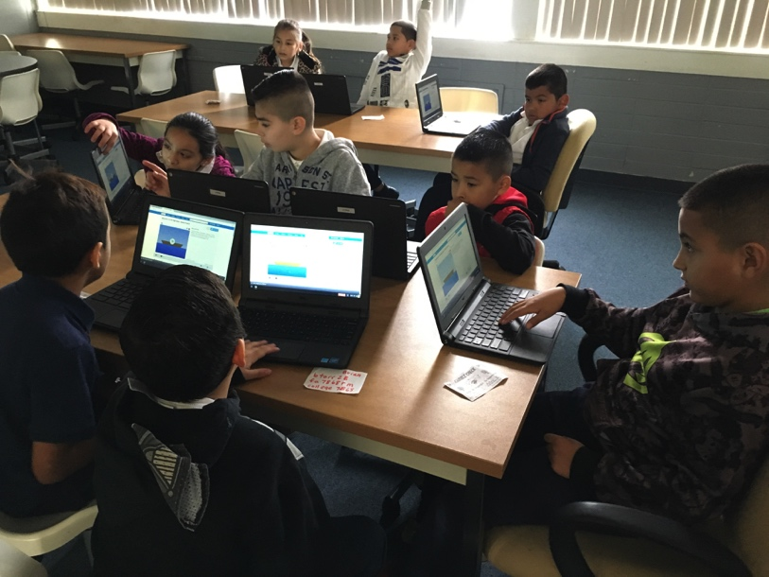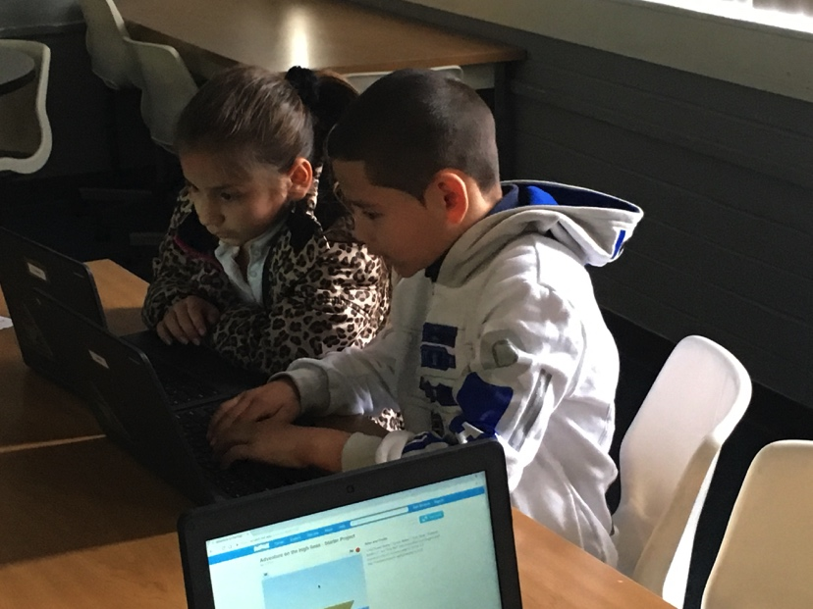

Ms. Krippendorf’s class participating in Hour of Code

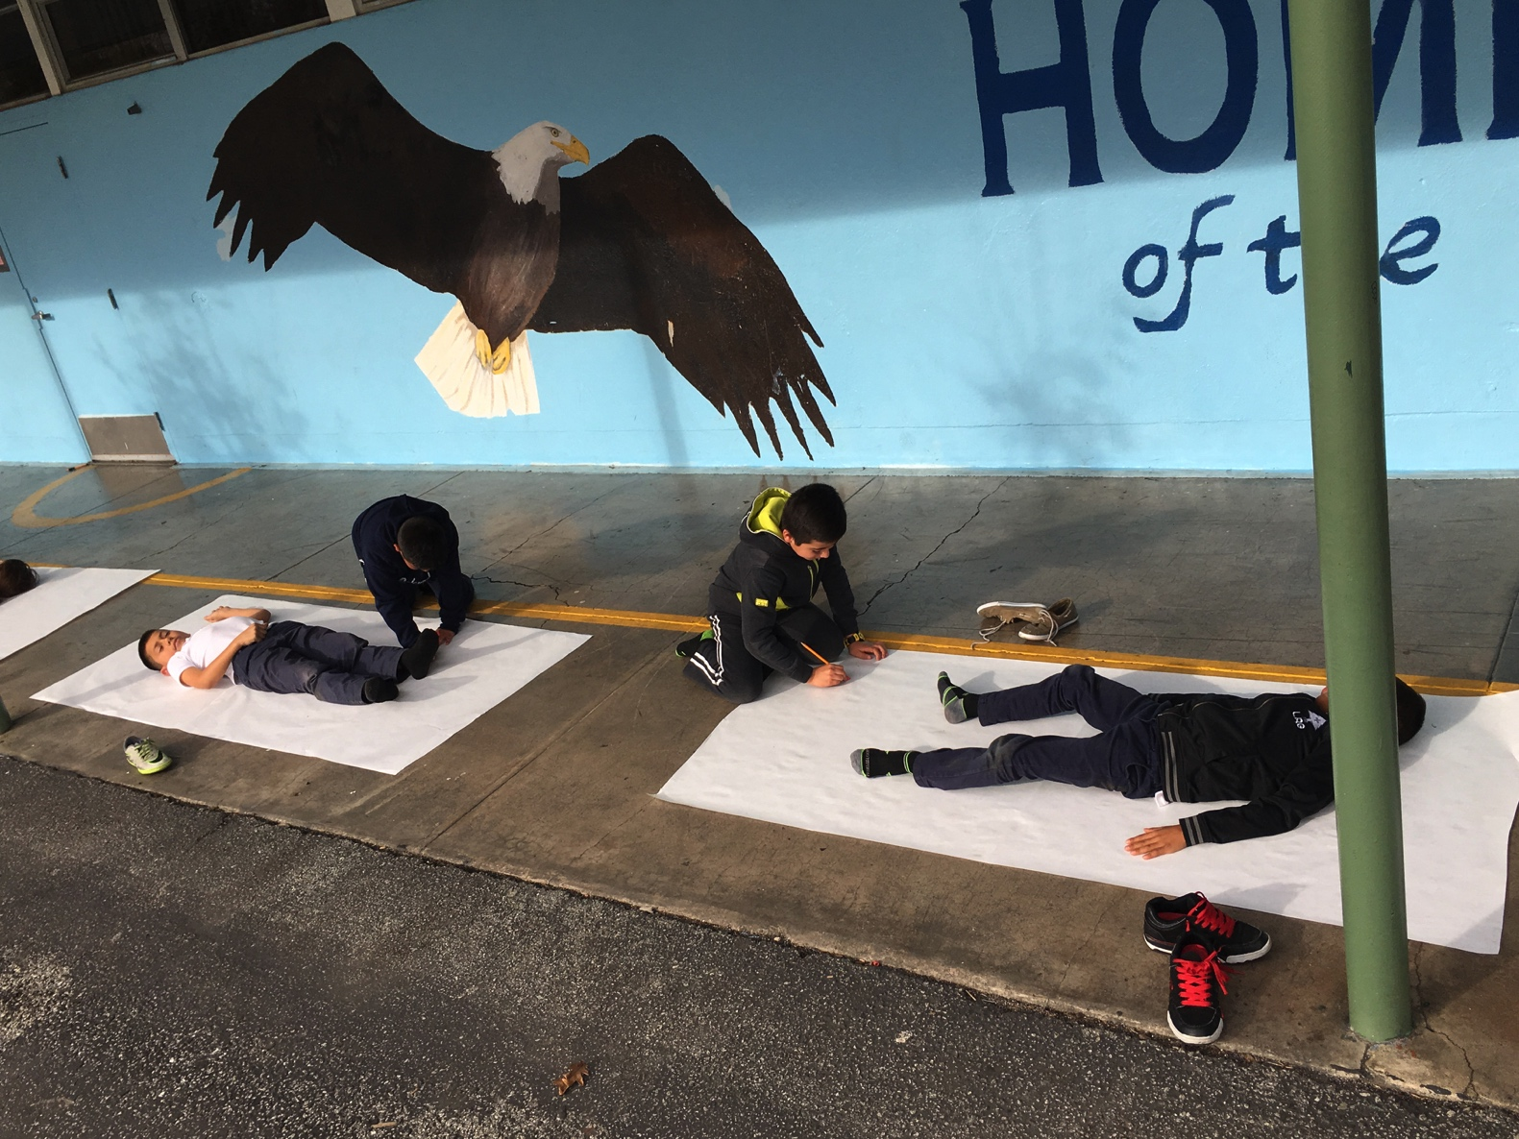
Ms. Soares’s class doing art

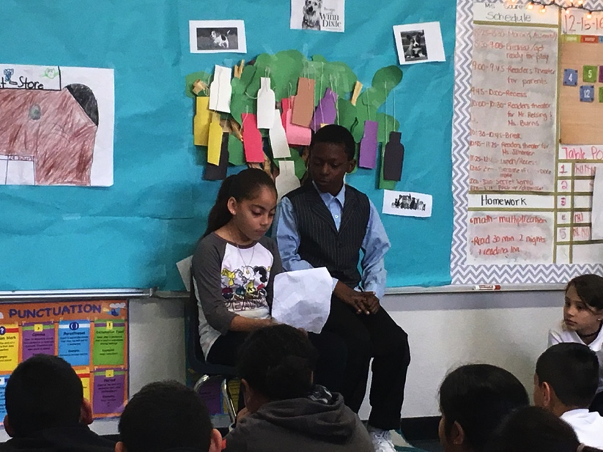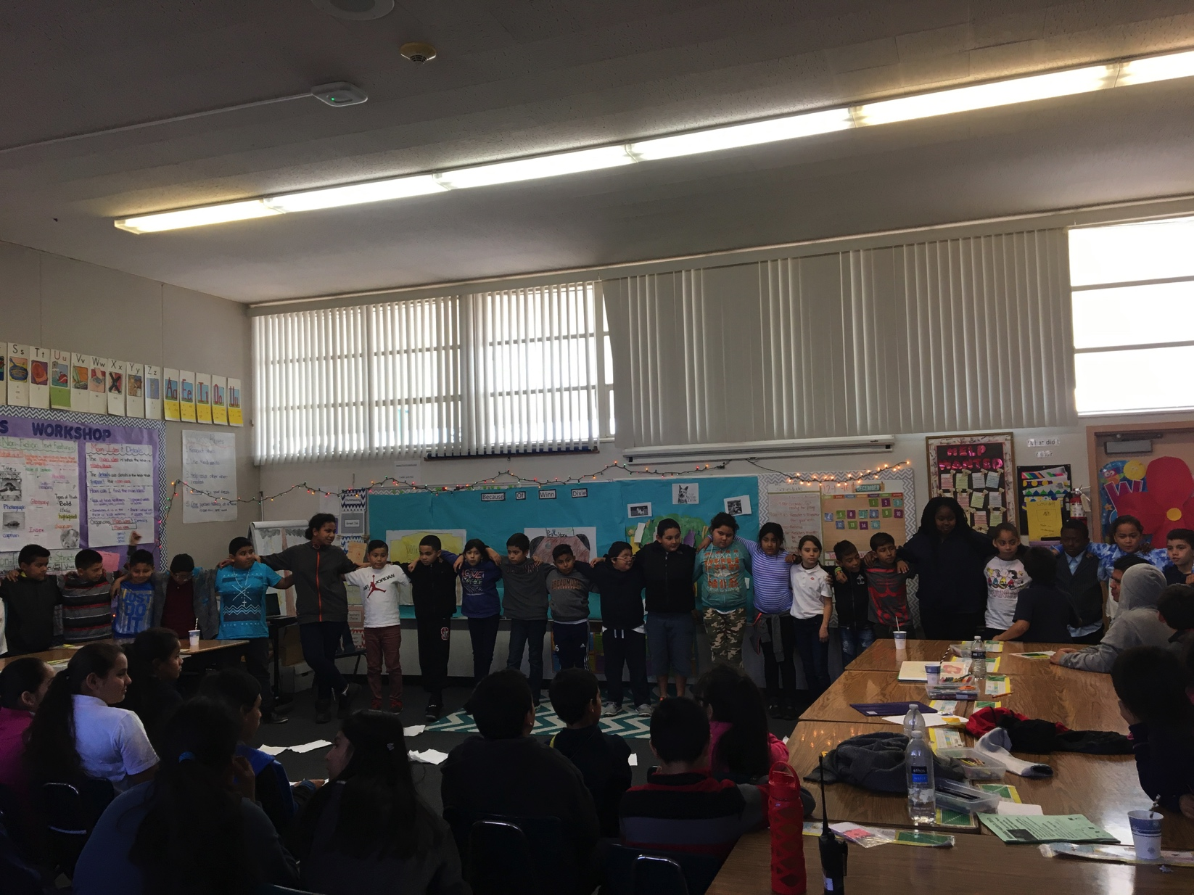
Because of Winn Dixe Play in Ms. Soares’s Class

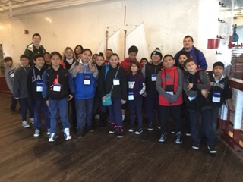
Ms. Johansen’s Class at the San Francisco Maritime Museum

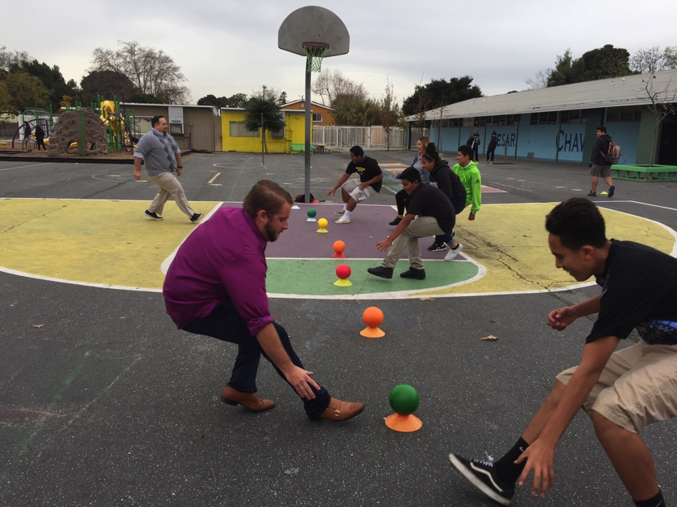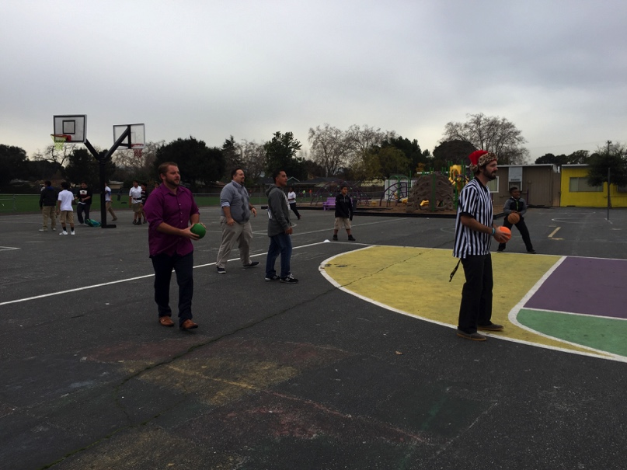
Impressive Dodge ball win by Staff against Middle School Students!
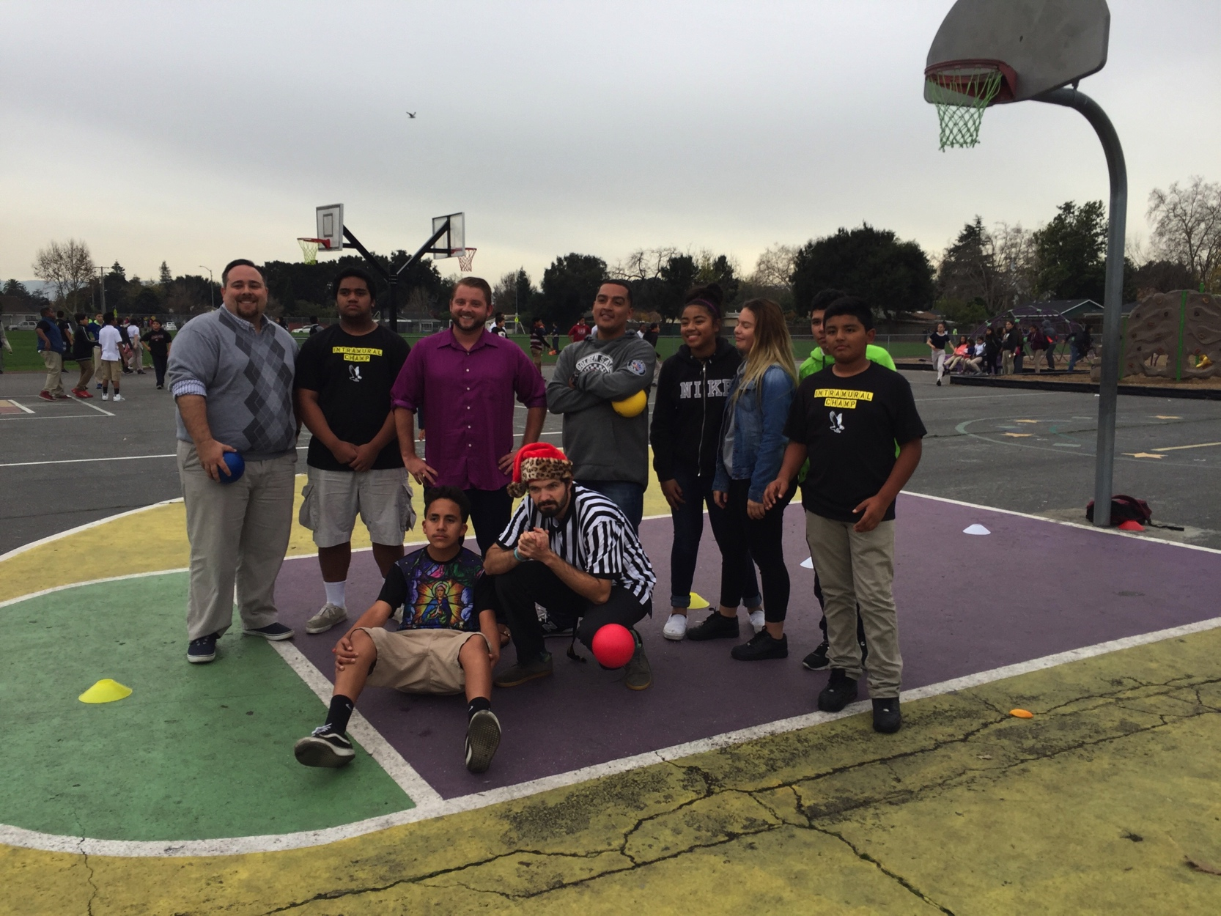

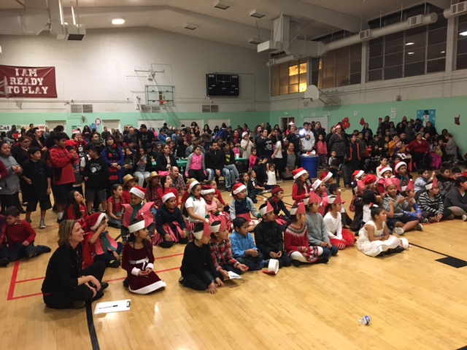
La Posada Celebration!
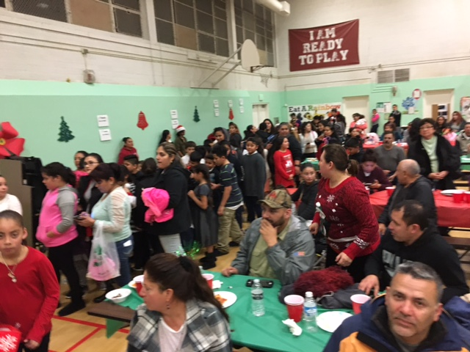

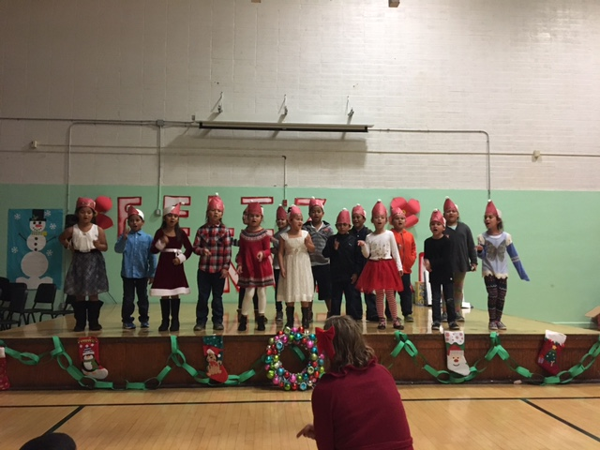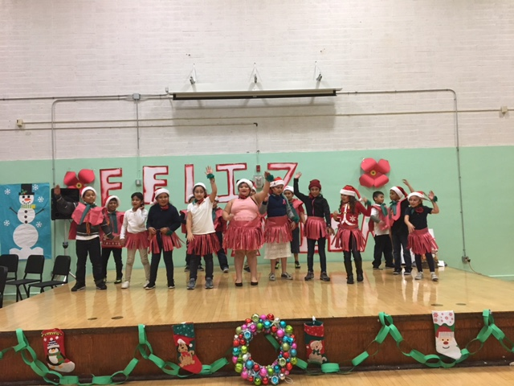
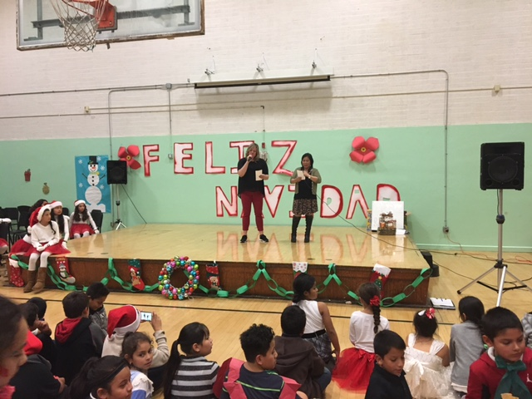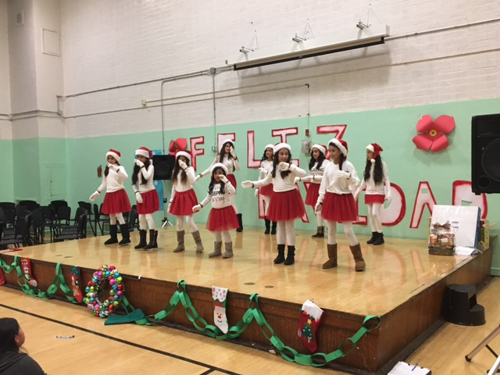
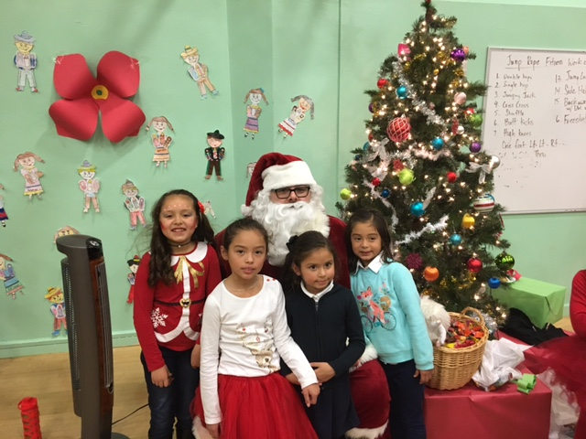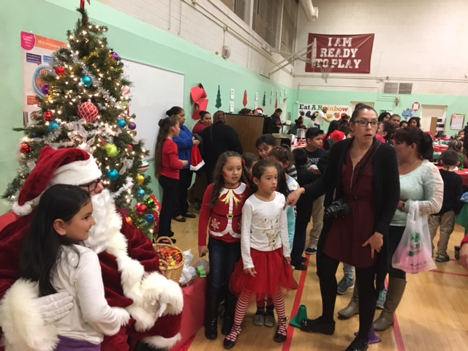

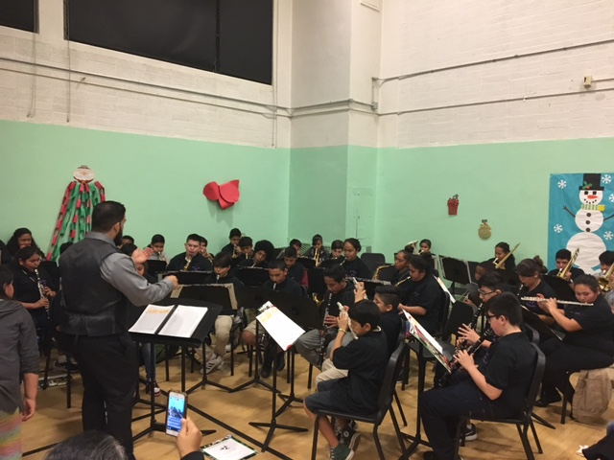
Band with Mr. Reyes
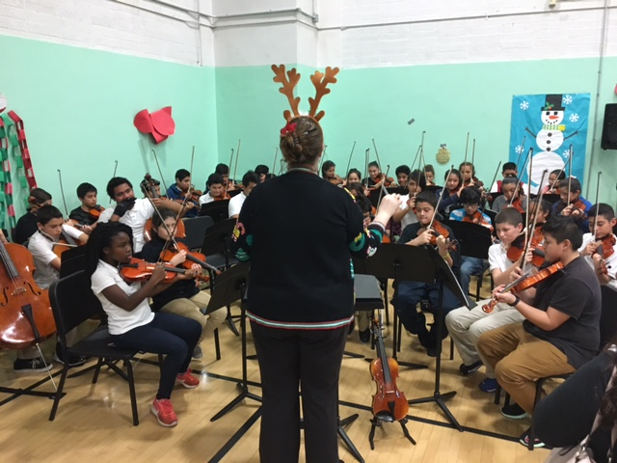
Orchestra with Ms. A

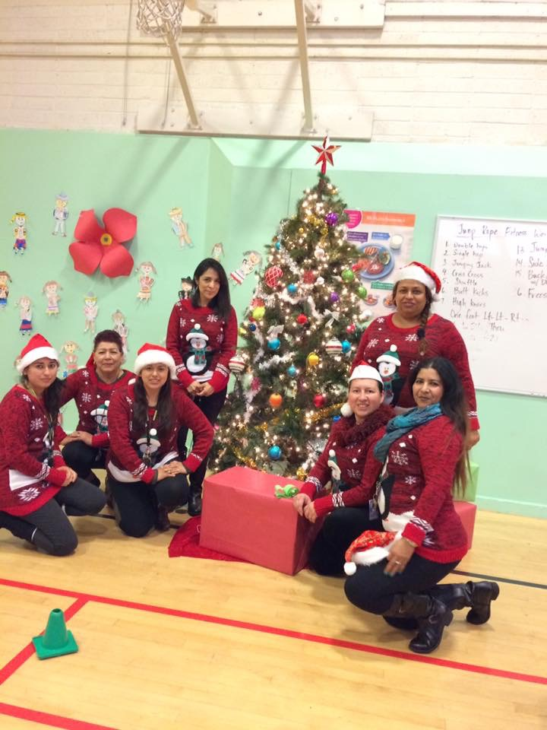

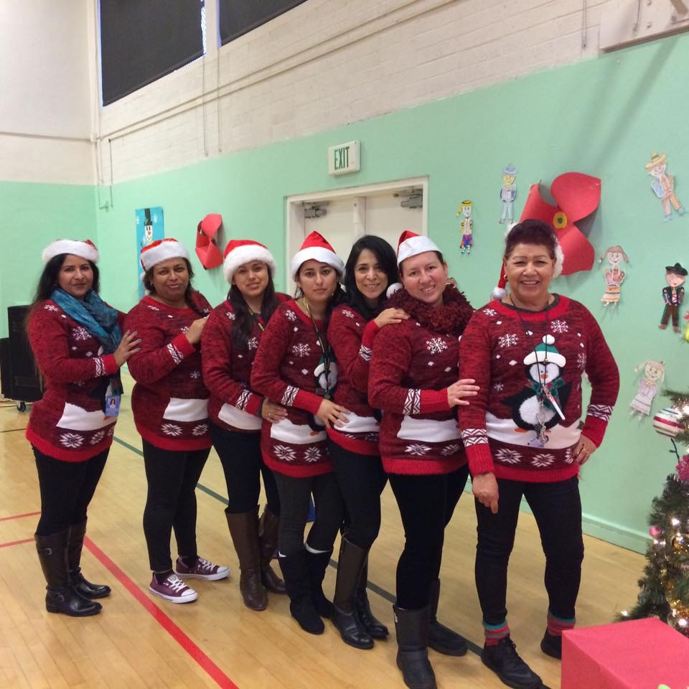

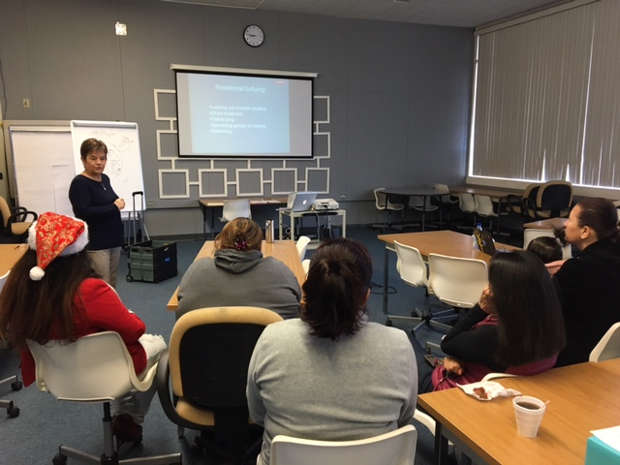
No Bully Workshop with Parents

