Take Home Tuesday
Parent Weekly Bulletin
January 11th to January 13th

Green Oaks Academy

Wednesday 1/11 | Thursday 1/12 | Friday 1/13
8:25 A.M. Start  3:10 P.M. Dismissal | 8:25 A.M. Start  3:10 P.M. Dismissal | 8:25 A.M. Start  Minimum Day  3:10 P.M. Dismissal  See you on Wednesday January 11, 2017!

Dear Parents and Families,
Welcome Back! We have missed you so much! We have exciting new additions to our school team! Mrs. Aurora Soria has joined the Newcomer Program Team at our school as a full-time Instructional Assistant to aid Newcomer Program students and families. Ms. Soaria previously worked in the office at Los Robles next door. Ms. Soria is also a parent at our school. She has two wonderful children who attend Green Oaks, Melanie and Rafael. These two kiddos are two of the nicest kids we have our school! We have two new teachers who have joined our middle school team. Ms. Shareika Robinson, who was previously a Paraeducator at our school, is our new 6th grade English Language Arts and Social Studies Teacher. Mr. Billy Kihara will be our new Health and Wellness instruction. He will join Coach Corsinotti and Ms. Carrell-Joe to complete our Physical Education department. Welcome aboard Ms. Soria, Ms. Robinson, and Mr. Kihara!

We received a generous donation in the form of Target Gift Cards from Moms Against Poverty. This is the same organization that provided gifts for our La Posada before the Winter Break. We will be doing a lottery and calling you to come in to pick up your gift card.

According to the weather, there will be a lot of rain in the month of January. It is important that you do not drop your children off before 8:00AM and pick them up every day on time. We want to ensure that students are not standing outside in the cold rain, especially during the storm that is supposed to occur this week. Please remember to dress your children in warm clothing and send them to school with an umbrella or raincoat. Thank you so much.

Finally, in observe of Martin Luther King Day, there will be NO SCHOOL on Monday January 16, 2017. Enjoy the time off, and hopefully the rain will go away by the weekend we can get some sunshine to enjoy the wonderful fresh air for the 3 day break!—Sincerely, Principal Bui

Photos before Winter Break for your Enjoyment

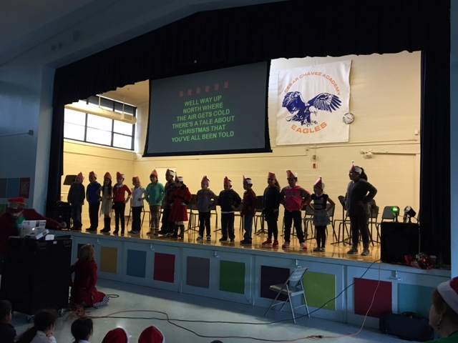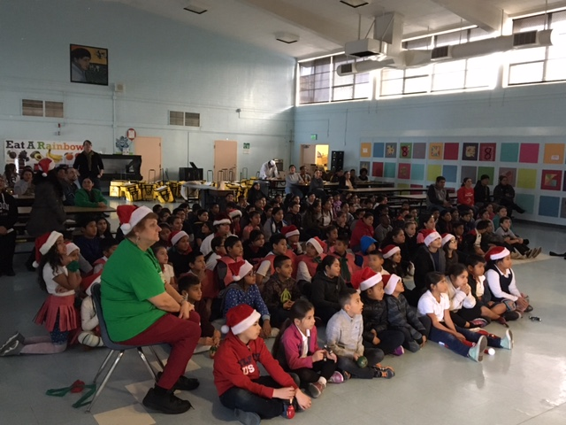
Elementary Holiday Sing A Long
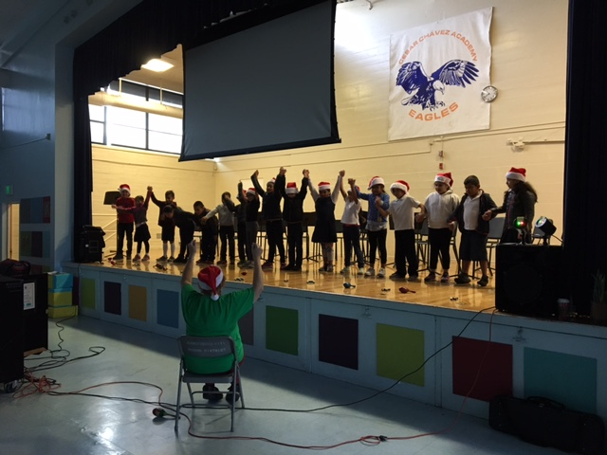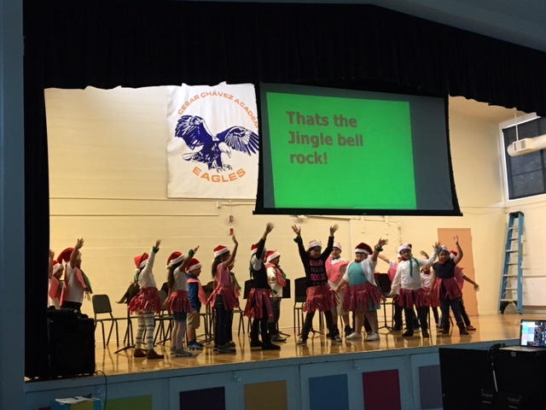
Great job with performances!
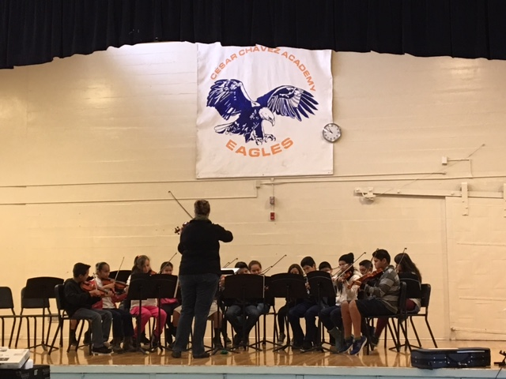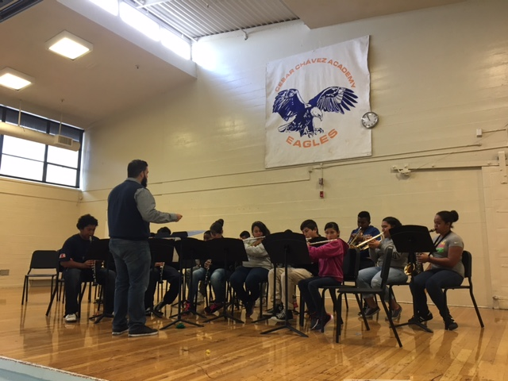
Thank you to Ms. A and Mr. Reyes for organizing the event!

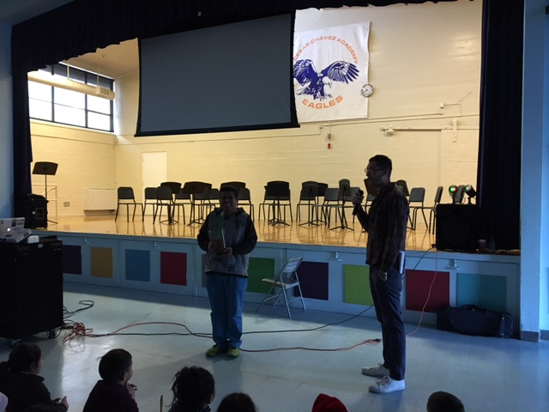
Mr. Jorge being honored with Outstanding ParaEducator Award
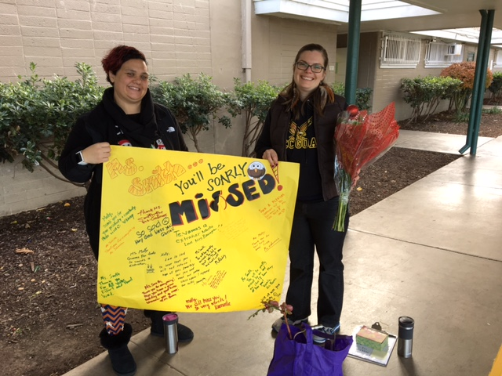
Ms. Smith’s Last Day with us. She will be very missed!

