Take Home Tuesday
Parent Weekly Bulletin
February 6th to February 10th

Green Oaks Academy

Monday 2/06 | Tuesday 2/07 | Wednesday 2/08 | Thursday 2/09 | Friday 2/10
8:25 A.M. Start  3:10 P.M. Dismissal | 8:25 A.M. Start  3:10 P.M. Dismissal | 8:25 A.M. Start  Minimum Day  1:10 P.M. Dismissal | 8:25 A.M. Start  3:10 P.M. Dismissal | 8:25 A.M. Start  3:10 P.M. Dismissal

Dear Parents and Families,

Future Chef Competition is back to the district this school year. It is opened to ALL grades Please see attached letter to you from our district to explain the details. There are specific deadlines and the competition will be on March 22 at our school. It was a great success with our students last year and this year we will have VIP judges and twice the fun with picture props. Every finalist will take home a GOLD Medal, Cookbook and their chef coats and hats. A picture of the GRAND PRIZE basket is also included.

Finally, as some of you may already know, I am expecting my second child sometime in February (let’s hope she comes on time!). While I am out, the Take Home Tuesdays will be written by our Vice Principals, Mr. Whitebread and Ms. Davis. They will also be available to meet with you to address any concerns that you may have. We will be in regular communication until I return, and we plan on talking every day on the phone. Please do not hesitate to reach out to these two wonderful Vice Principals if you need help. I can also speak with you over the phone for matters that are very urgent to ensure that your voice is heard.—Sincerely, Principal Bui

Photos of previous week for your enjoyment!
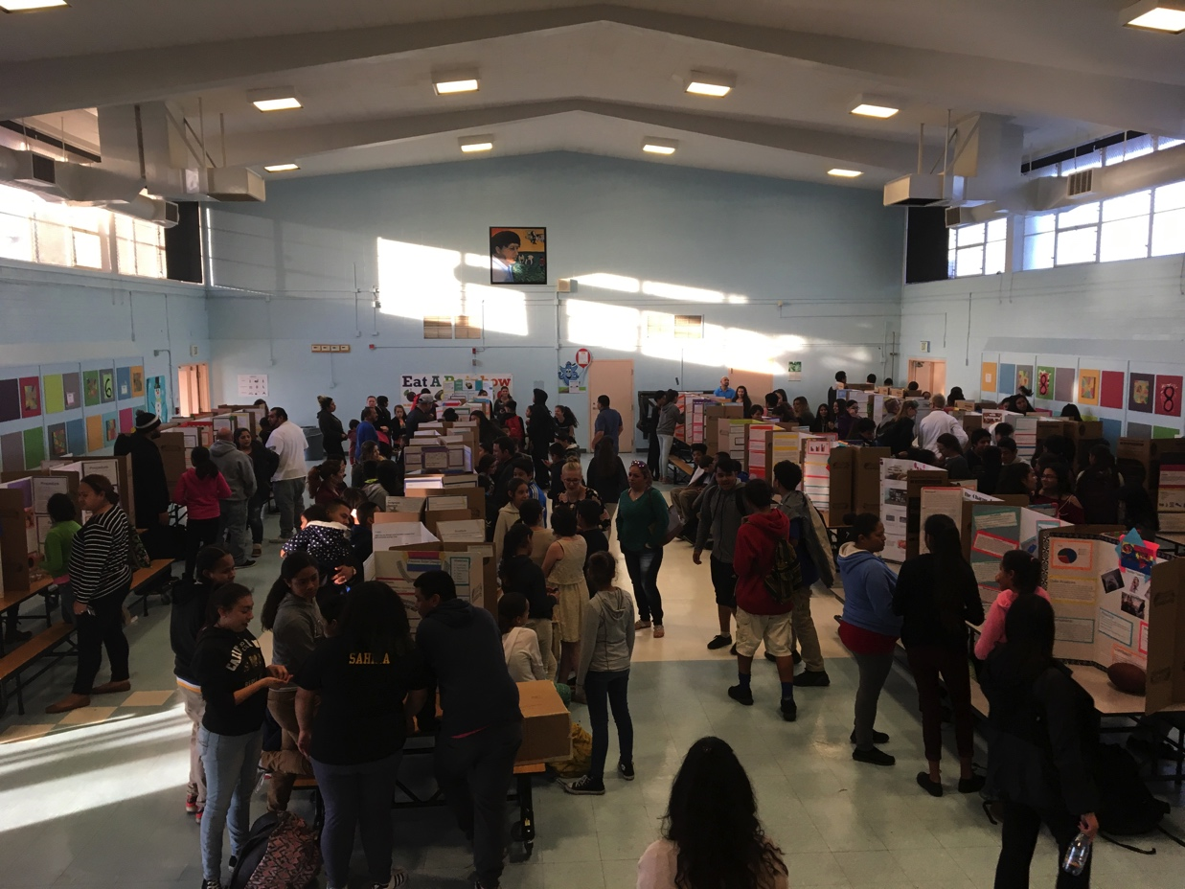

STEM Fair
S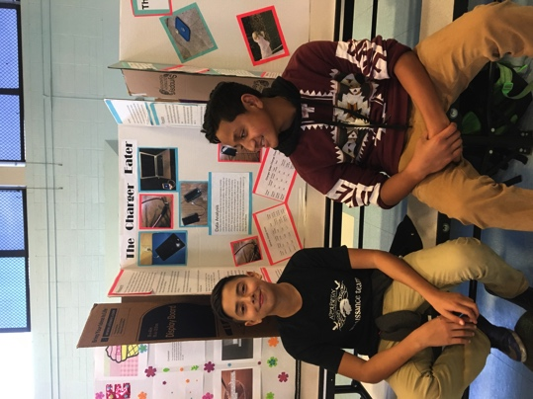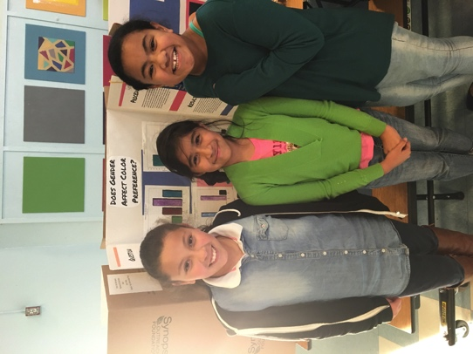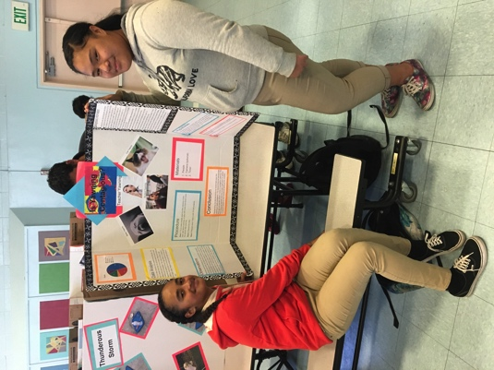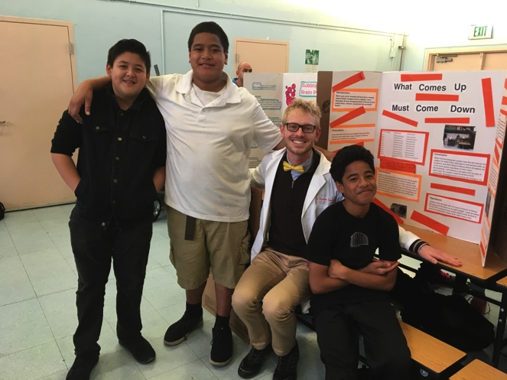

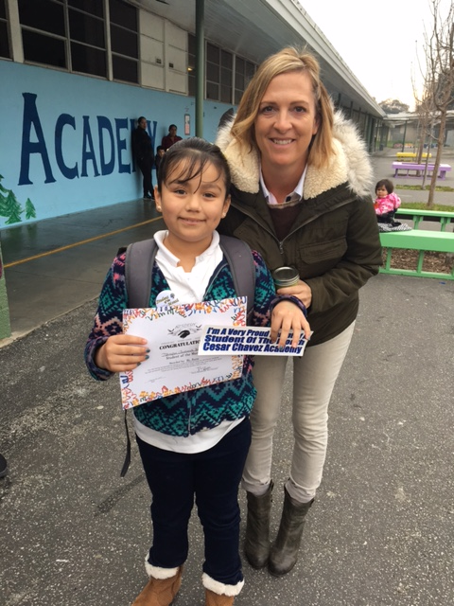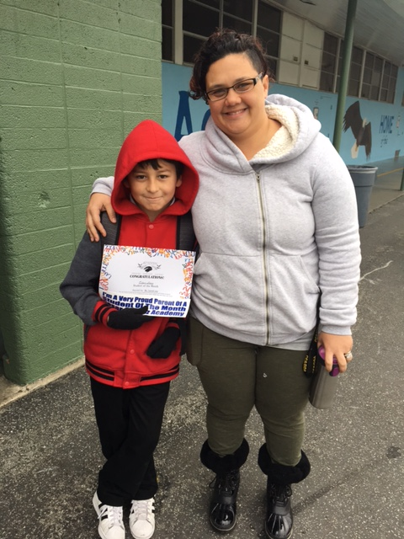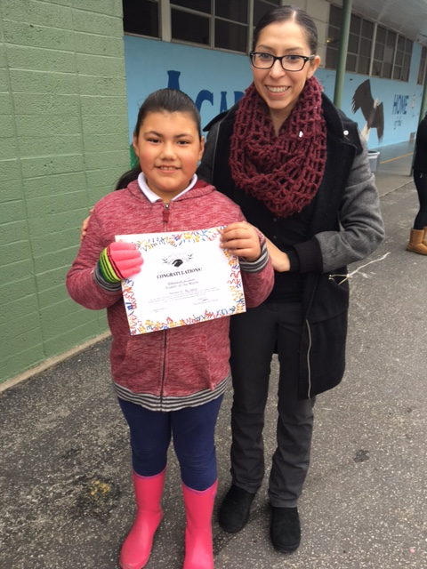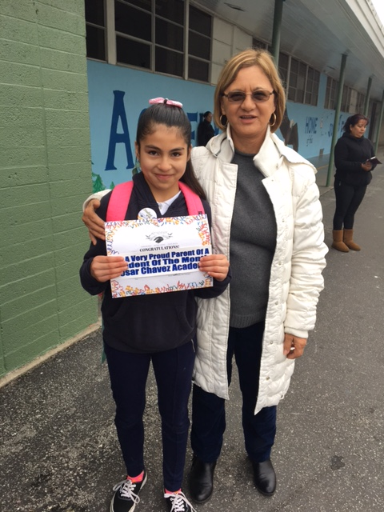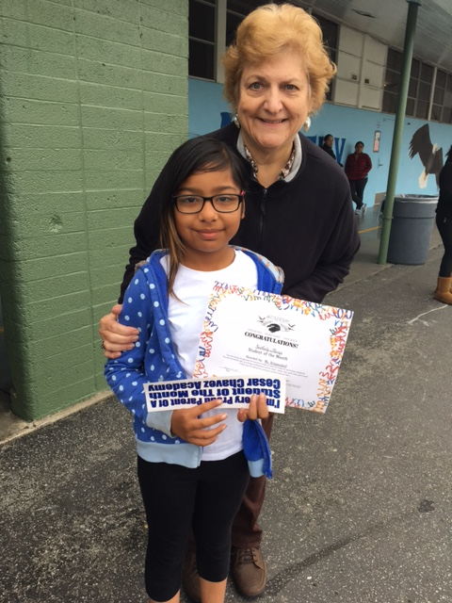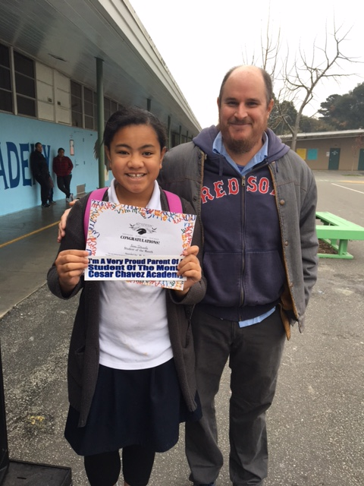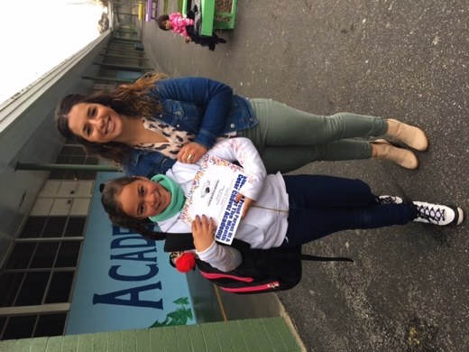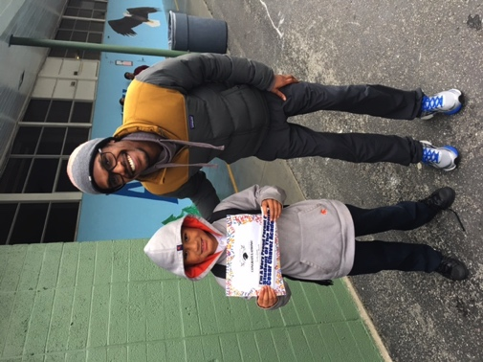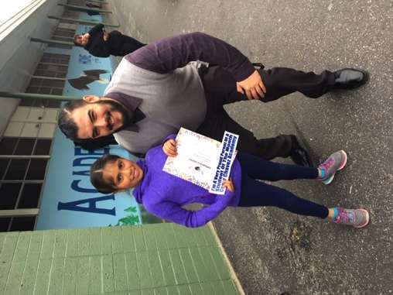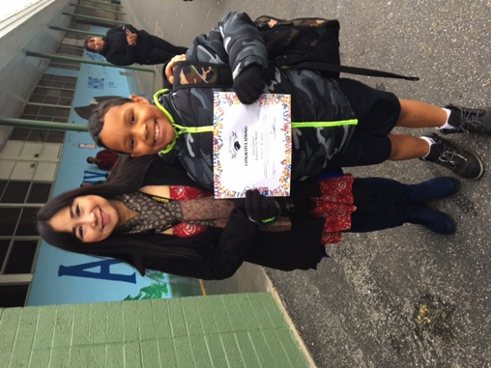

Green Oaks January Students of the Month

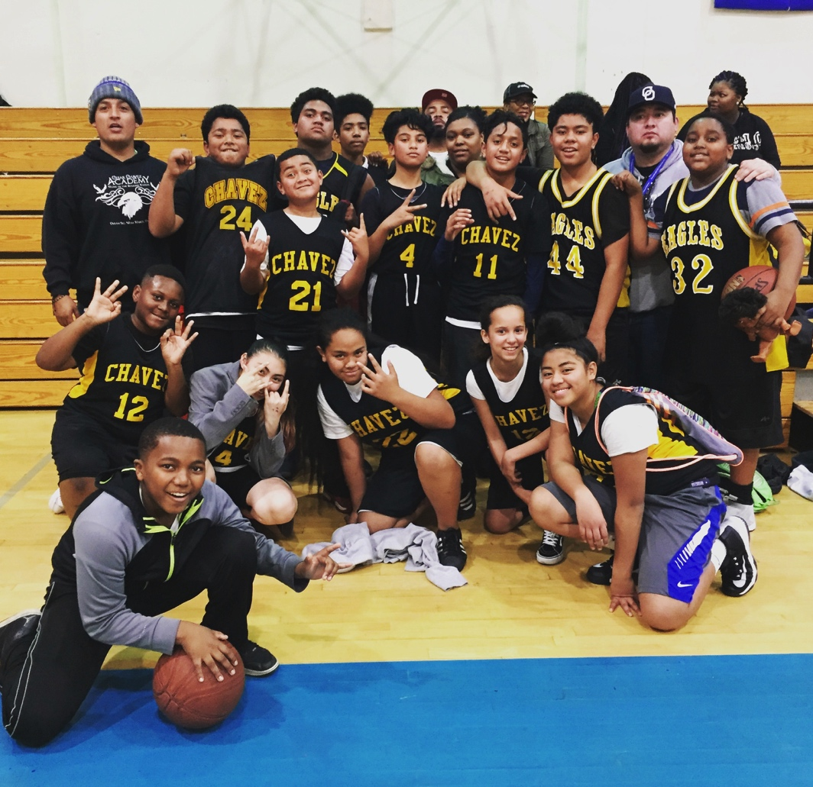
Congrats to both our basketball teams! Both the Girl’s and Boy’s League won their first game!
