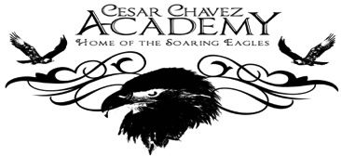
Take Home Tuesday
Parent Weekly Bulletin
November 7th to November 11th

Green Oaks Academy

Monday 11/07 | Tuesday 11/08 | Wednesday 11/09 | Thursday 11/10 | Friday 11/11
8:25 A.M. Start  3:10 P.M. Dismissal | 8:25 A.M. Start  3:10 P.M. Dismissal | 8:25 A.M. Start  Minimum Day  1:10 P.M. Dismissal | 8:25 A.M. Start  3:10 P.M. Dismissal  Second Harvest  4:00-6:00PM | No School! Happy Veteran’s Day

Dear Parents and Families,
Next Week November 15th to November 18th is our Parent Teacher Conferences. This is your opportunity to meet with your child’s teacher(s) to get an idea of how he or she is doing in school, and to ask important questions. The purpose of the conference is for you to determine ways you can work with the teacher to support your child’s learning and growth at our school. Last week, I met with School Site Council and ELAC to brainstorm questions they believe every parent should as their child’s teacher(s) at these conferences. Please review the questions below and keep them in mind when you come to speak with your child’s teacher(s) next week. We will also have a poster of these questions displayed by the front office to remind you.
Questions to ask your child’s teacher(s) during Parent-Teacher-Conferences.
- How is my student achieving?
- What’s going on? What is hard in your class?
- How is my child doing in the class? How can I help?
- Is my child turning in their homework? How can I know if my child has homework and what is expected of them to get an “A” in the class?
- Do you accept late assignments? Can my child red-do them for extra credit?
- How is my child being graded?
- For elementary only—What is my child’s reading level? Where should he/she be by our next meeting?
Have a wonderful 3 day weekend! Thank you to our veterans for all they have done!—Sincerely, Principal Bui

Photos of the previous week for your enjoyment!

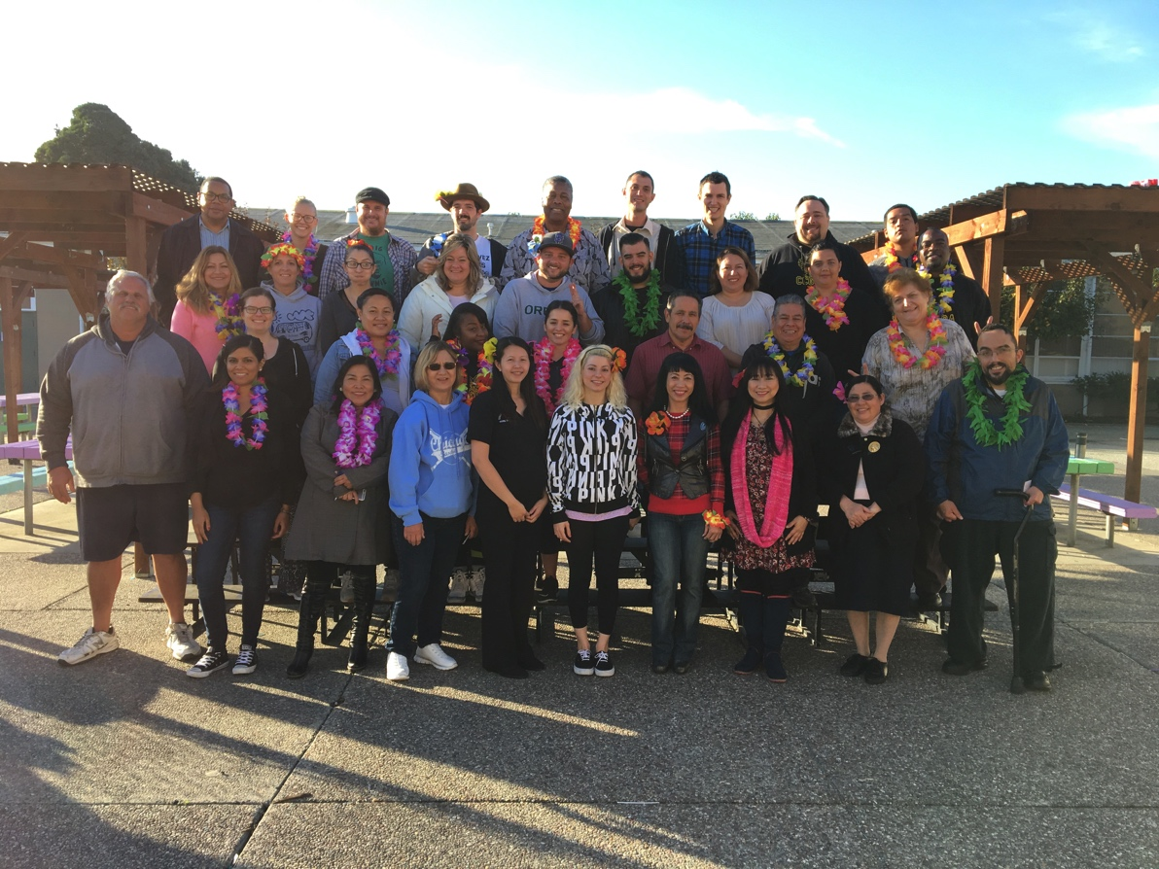
Cesar Chavez Green Oaks Staff Photo

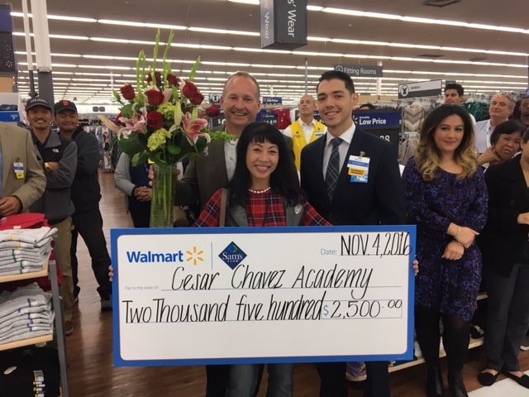
Ms. Nguyen receiving the Walmart Educator Grant!

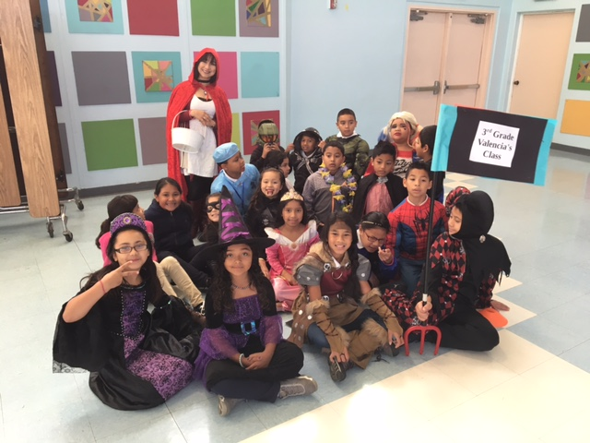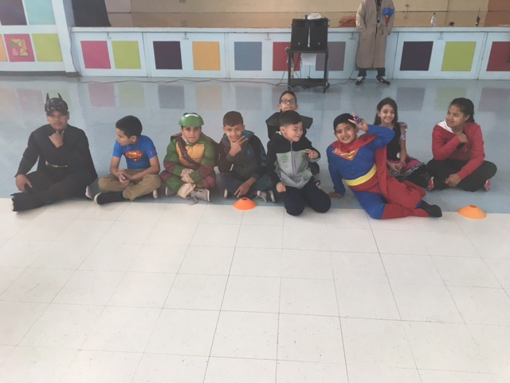

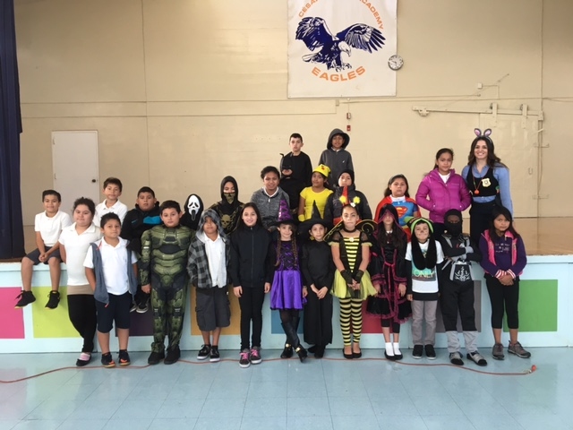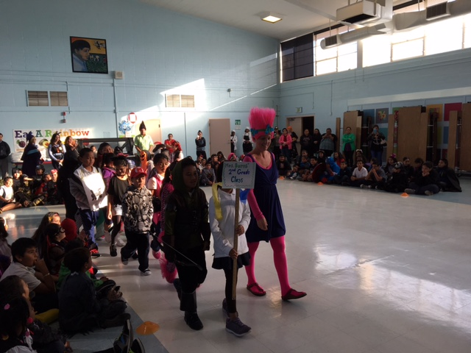

Green Oaks Halloween Parade

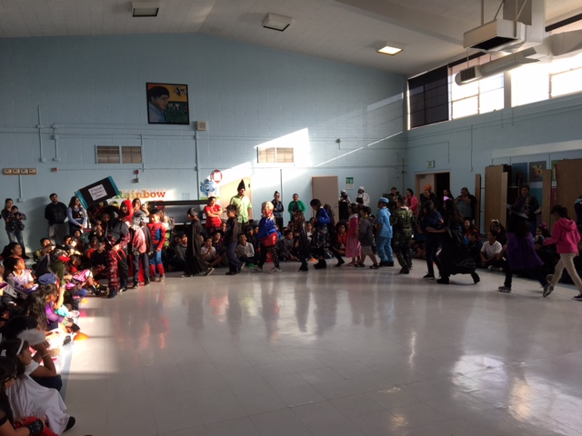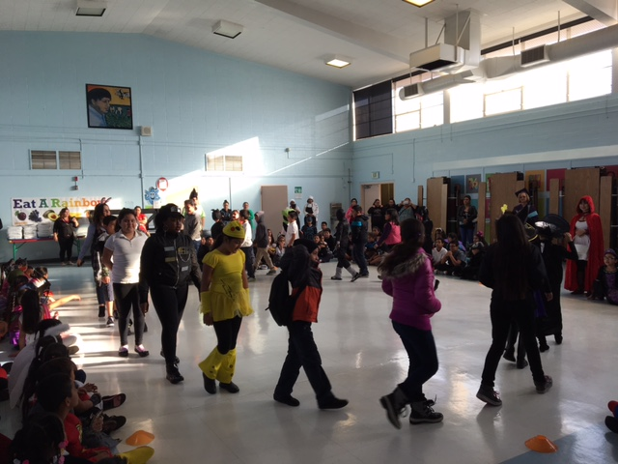

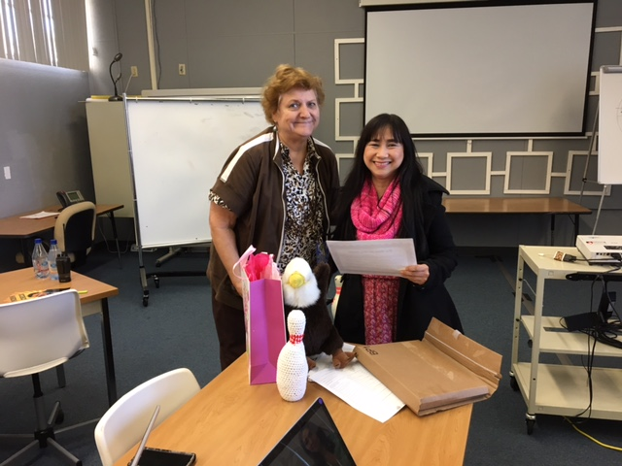
Mrs. Krippendorf receiving an award from Ms. Valencia
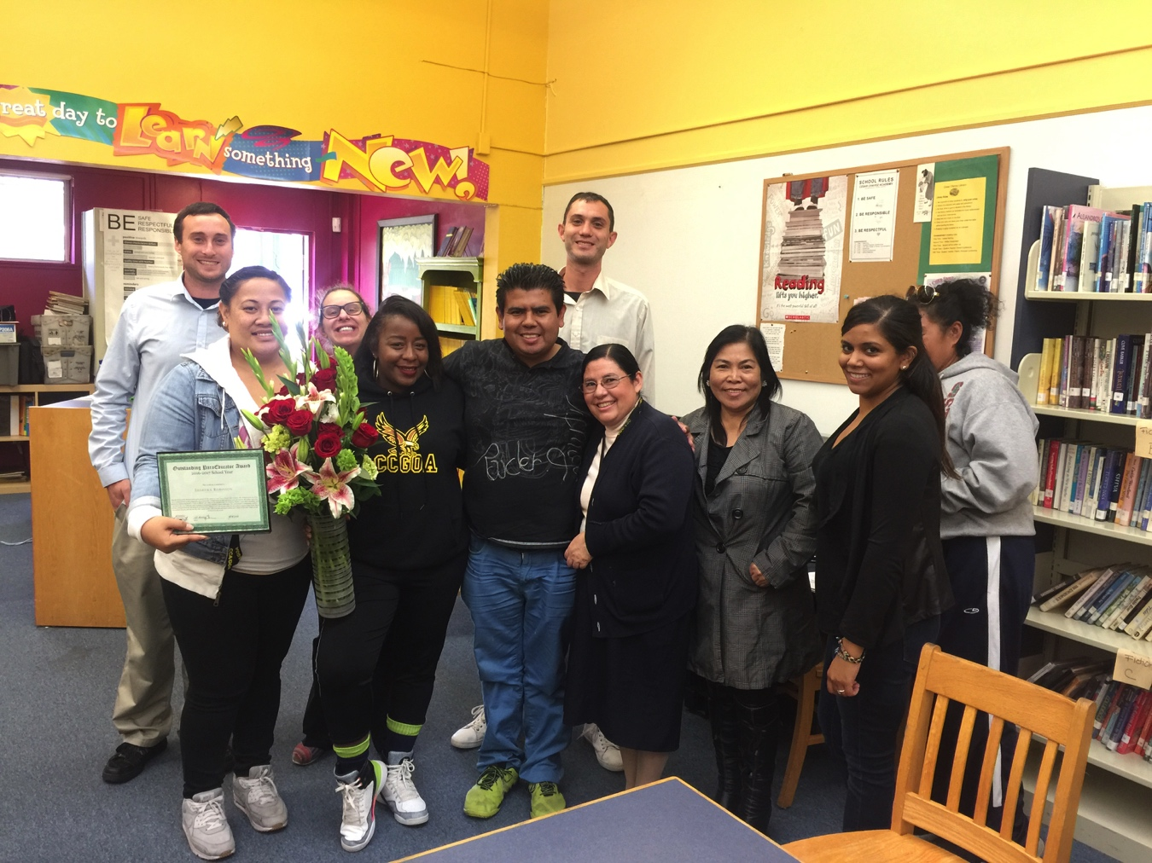
Ms. Robinson receiving the Outstanding ParaEducator Award

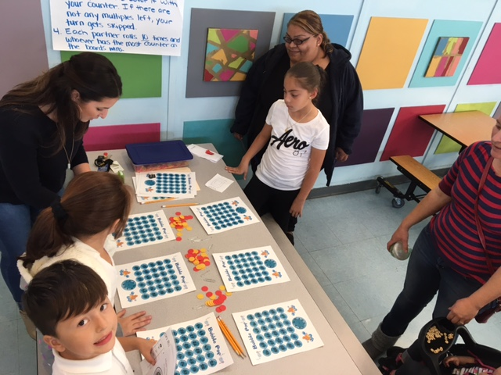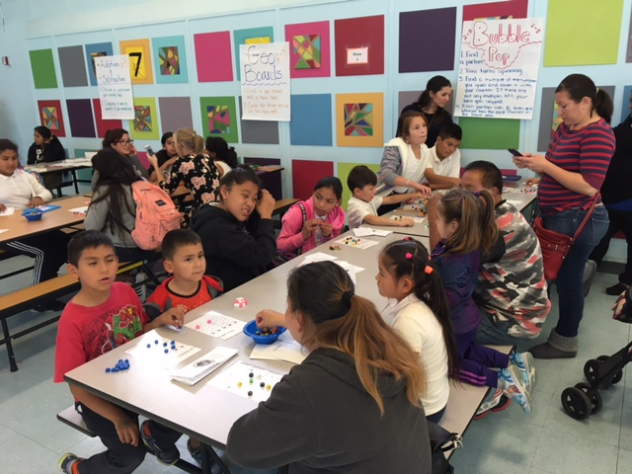
Family Math Night!
