Take Home Tuesday
Parent Weekly Bulletin
October 3rd to October 7th

Green Oaks Academy

Monday 10/03 | Tuesday 10/04 | Wednesday 10/04 | Thursday 10/06 | Friday 10/07
8:25 A.M. Start  3:10 P.M. Dismissall | 8:25 A.M. Start  3:10 P.M. Dismissal  School Site Council/ELAC Meeting  3:15-4:00PM | 8:25 A.M. Start  Minimum Day  1:10 P.M. Dismissal | 8:25 A.M. Start  3:10 P.M. Dismissal  Second Harvest in Cafeteria  2:00-6:00PM | 8:25 A.M. Start  3:10 P.M. Dismissal

Dear Parents and Families,

I invite you to check out our Take Home Tuesdays on our our website at: http://ccagoa.weebly.com/. You can also pick up copies in the front office, available in both English and Spanish. We will also have resources for parents available on the website.

I would like to take this opportunity to introduce you to our 2016-2017 School Site Council and ELAC members. You have elected Ms. Marbella Vega, Mr. Gerardo Hernandez, Mr. Cornell Garland, Mr. Marco Duarte, and Ms. Nancy Alvarez. The first meeting of the year is this Tuesday October 3rd in the Library. If you have any issues you’d like to raise to be put on the agenda, please contact one of these parents to inform me to put your concern on our agenda. The purpose of this first meeting is to go over our bylaws, establish our goal/vision for the school year, and to elect officers.

Finally, Congratulations to our soccer team. We are victorious yet again! Boys won 2 to 0 and Girls won 3 to 1!! Have an awesome week, enjoy the beautiful weather while it lasts !—Sincerely Principal
Photos of the previous week for your enjoyment!
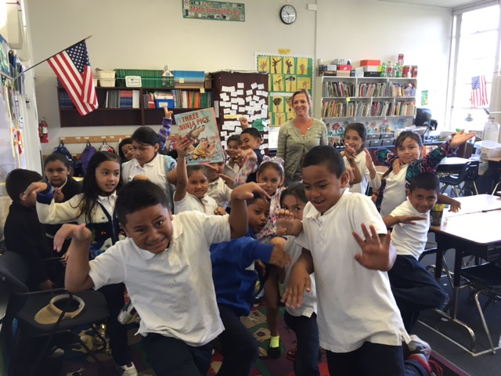
Ms. Burns’s student reenacting a scene from the book Three Ninja Pigs
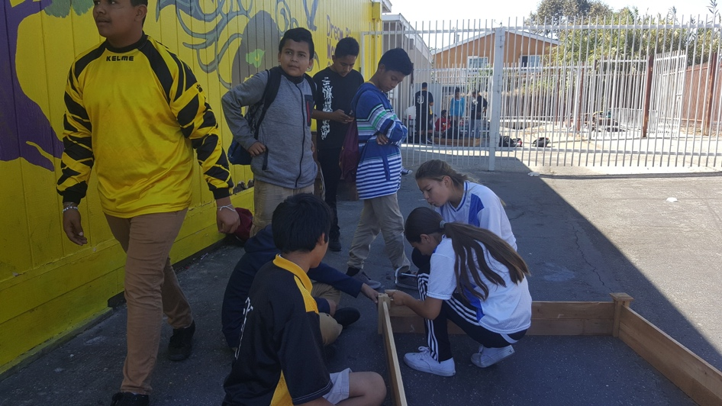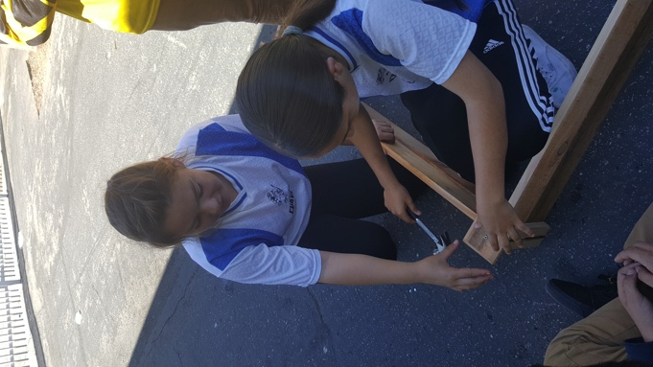
Students in ASP installing planter boxes

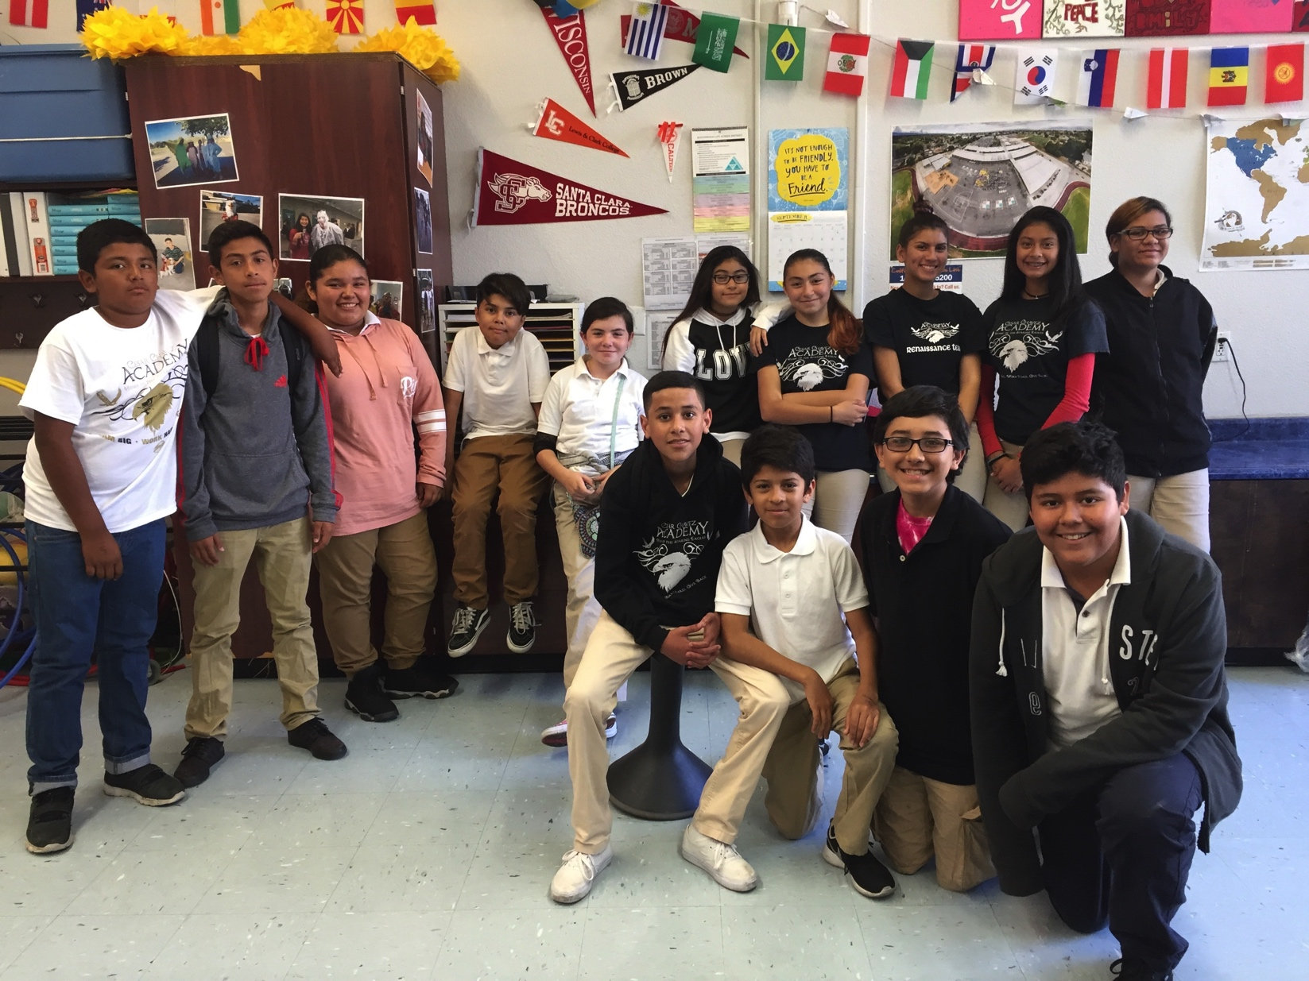
Your 2016-2017 Renaissance Team!!

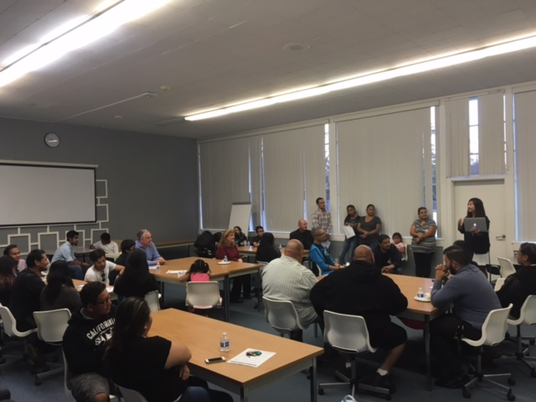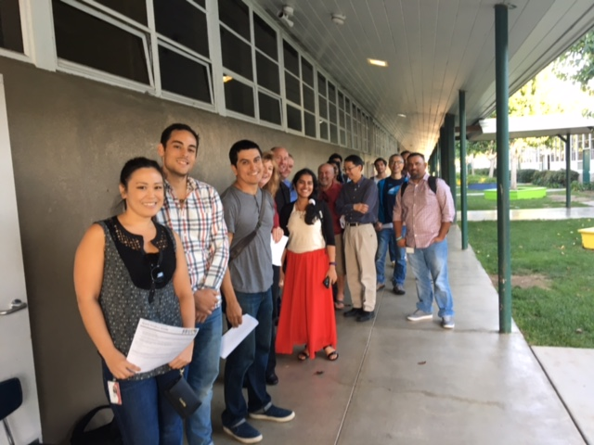

SPARK Match Night

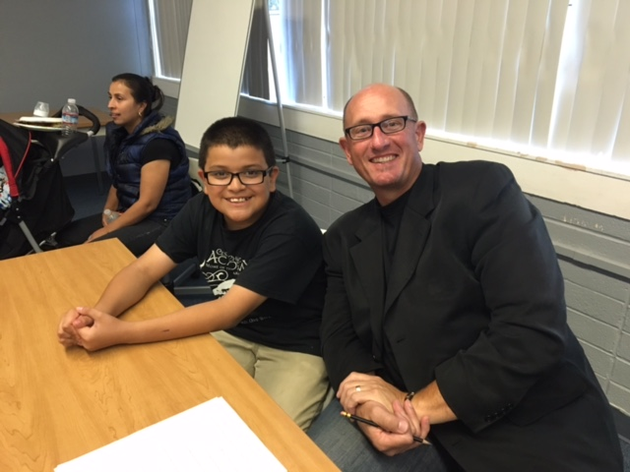
7th/8th grade students and parents met their mentors for the first time. Students will begin their internships next week at Cisco, Adobe, or PayPal in San Jose

